**‘Get Creative Festival’ in Didsbury Library**

**The Library will be delighted to take part to the festival by hosting a FREE art activity for both adults and children in cooperation with Enza Stellato Artist (**[**www.artistenza.com**](http://www.artistenza.com)

**FB Artistenza) who will facilitate the activity**

**MAKE YOUR WISH AND DRAW YOUR UNIQUE WELL TO PUT IT IN**

**Saturday 18th May 2019 - between 14:00-15:30**

**Join Enza in the library, she will have a variety of ideas to help you draw the well of your wishes.**

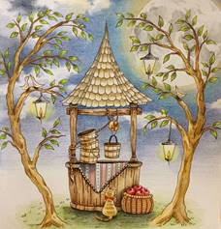

***Drawing by: anonymous from Pinterest***

**Get some inspiration of what you can draw and set your intention for a wish or two and use the process of drawing to focus on what you wish for, then use the high spirits of the summer to work towards it and make it come true.**

**No experience or drawing skills needed for this activity, only your presence of mind for the creation of your wishing well.**

*Basic materials will be supplied, although you can bring your special drawing pad, diary, sketch book or other materials to work on.*